|  |  |
| --- | --- |
| Team ID | PNT2022TMID42646 |
| Project Name | Smart Farmer - IoT Enabled Smart Farming Application |

**Node-RED:**

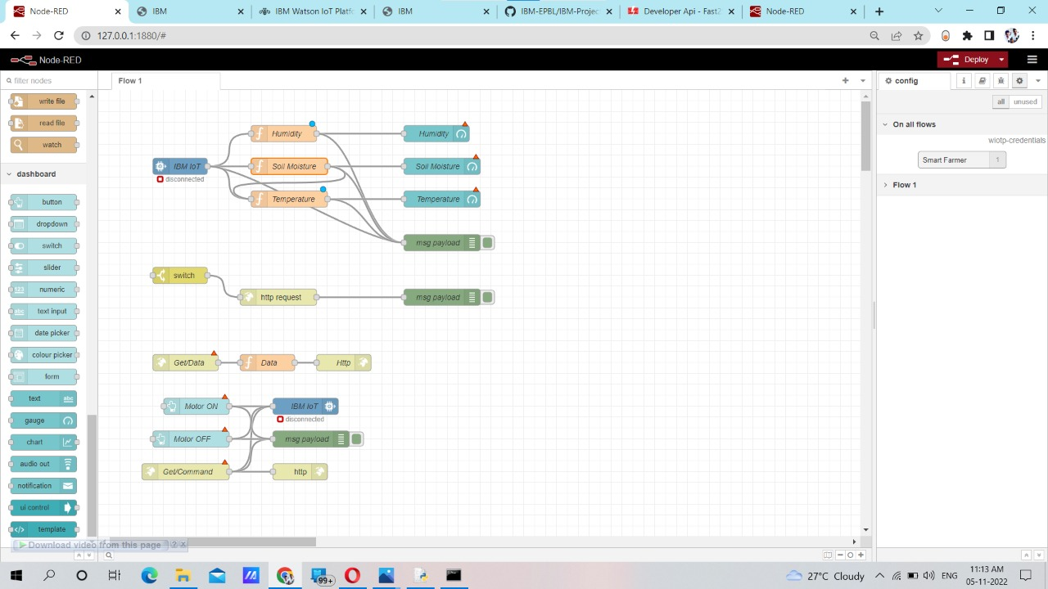

**IBM Watson Platform**

